
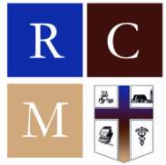
Resurrection Catholic Church
2815 Forbes Drive
Montgomery, Alabama 36110
Tel: 334-263-4221
www.rcmsouth.org
Fr. Manuel Williams, C.R., Pastor
Sr. Gilda Marie Bell, Minister of Care (334) 230-1952 Mr. Leon Moore, Parish Council President
Mrs. Michelle Coe, Administrative Assistant (334) 230-1964 Mr. W. Clifford Petty, Pastoral Musician (334) 230-1963
MASS SCHEDULE: Sunday – 9:00 a.m.; visit www.rcmsouth.org for virtual Mass; Thursday – 10:00 a.m. (School Mass)
DECEMBER 21, 2025 – THE FOURTH SUNDAY OF ADVENT (WELCOME HOME sUNDAY)
21 DE dICIEMBRE DE 2025 – 4º domingo de Adviento

The parish online giving link for sacrificial giving is https://osvhub.com/rcmsouth/giving/funds or click the QR code.
SACRIFICIAL GIVING: Thanks be to God and to you for your support of your Church last Sunday. May God continue to inspire us to share time, talent and treasure with this faith community.
Sunday Collection Basket and Mailed Offerings: $ 4,645.00
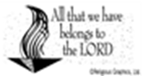
Online $ 1,023.00
Second Collection: Retired Religious $ 20.00
Building Fund $ 75.00
Food Pantry $ 75.00
School $ 50.00
OFFICE CLOSURES
The Parish and Mission Offices will be closed on Wednesday, Thursday and Friday, December 24-26, 2025 to observe the Nativity of the Lord. The school will be closed until January 5, 2026. The Mission and Parish offices will be reopen on Monday, December 29, 2025.
CHRISTMAS MIDNIGHT MASS
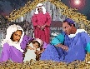
Come share in a night of word, music and dance, as we welcome our newborn King! Midnight Mass will be celebrated on Wednesday, December 24. A prelude of melodious music of the season will begin at 11:30 p.m. Christmas Day Mass will be celebrated at 10:00 a.m.

CHRISTMAS GREETING
The Christmas Spirit is the Holy Spirit that lets us love each other. Let the spirit of love gently fill our hearts. Let us remember God’s gift to the world. Not just for Christmas, but for every single day. May peace be your gift at Christmas and your blessing all year through! Fr. Manuel, and Your Pastoral Staff
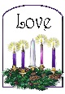
the FOURTH Sunday of Advent (LOVE)
Today the Church celebrates the Fourth and final Sunday of Advent. "Hail, full of grace! The Lord is with you." But she was greatly troubled at what was said and pondered what sort of greeting this might be. Then the angel said to her, "Do not be afraid, Mary, for you have found favor with God. "Behold, you will conceive in your womb and bear a son, and you shall name him Jesus. He will be great and will be called Son of the Most High, and the Lord God will give him the throne of David his father, and he will rule over the house of Jacob forever, and of his kingdom there will be no end." (Luke 1:28-33)
O Rex Gentium (O King of the Nations) is the Sixth of the O Antiphons. A certain nobleman went into a far country to receive for himself a kingdom and to return" (Luke 19:12). This nobleman is Christ, the Son of God, King of all nations. His kingdom is over all men and over all things, both material and spiritual. He has everything in His hand as God and man. But another, Satan, has broken into His kingdom and has made himself master of many of Christ's subjects. In the old dispensation only a small part of humanity, the chosen people, remained faithful to the almighty King.
Christ, the Son of God, came into this "far country" in order to become man and, by means of humility, obedience, and poverty, to cast out the usurper who had taken His subjects. He came to reassert His dominion over all those who had left Him, both Jews and Gentiles.!.
https://www.catholicculture.org/culture/liturgicalyear/calendar/day.cfm?date=2024-12-22.
CONTACTS IN THE PARISH AND MISSION CENTER
Apostles of the Resurrection Evelyn Harris
Apostolate for Persons with Disabilities Angela Barnes
Archdiocesan Pastoral Council Gladys Copeland
Altar Servers Keith Golson, Leon Moore
Baptism Classes Regina Sadler
Bulletin Michelle Coe
Burse Club Kelley Calloway
Choir, Adult W. Clifford Petty
Church Environment Thelma Williams, Erma Carter
Confirmation Class Leon Moore, Vonzetta Graham
Eucharistic Ministers Fr. Manuel Williams, C.R., Sr. Gilda Bell
Hospitality Committee Wanda Twitty
Interfaith Community Outreach Michelle Coe
Knights of Peter Claver Grand Knight Grand Knight W. Clifford Petty
Knights of Peter Claver Deputy Grand Knight Knight Carlton Robinson
Knights of Peter Claver, Ladies Auxiliary Grand Lady Grand Lady Rosalind Pijeaux Hale - kpcla345gl@gmail.com
KPCLA, Vice Grand Lady Lady Pamela Garrett
Knights of Peter Claver Jr. Daughter Counselor Lady Melvetta Leach-Peck
Knights of Peter Claver Asst. Jr. Daughter Counselor Lady Daphne Hawkins
Knights of Peter Claver Jr. Knight Commander Knight Clif Weatherly
Lectors Airy Thomas
Liturgical Dancers Erica Brooks, Linda Carpenter, Nora Powell May
Marriage Preparation Fr. Manuel Williams, C.R.
Mass Program/Worship Aid W. Clifford Petty
Pastoral Care / Minister of Care Fr. Manuel Williams, C.R. / Sr. Gilda Bell
Nazareth /Resurrection Alumni Organization
Notary Public Michelle Coe
Our Lady Sodality President, Tina Golson
Parish Council President, Leon Moore
Religious Education Regina Sadler
RCIA Fr. Manuel C.R., Sr. Gilda Bell, Leon Moore
Resurrection Catholic School Principal, Dr. Teisha Pessoa
Resurrection Catholic School PTO
Resurrection Catholic School Child Nutrition Program Manager, Ms. Twila Webster
Youth Ministry Brandon Anderson, Erica Brooks, Linda Carpenter
PRAY FOR THE UNBORN: The Rosary is said every 2nd Sunday before Mass. Please join us in the Sanctuary.
SACRAMENT OF BAPTISM: Call the parish office to schedule a baptism class as well as a date for the baptism.
RECONCILIATION is celebrated before Mass, and by appointment.
SACRAMENT OF MARRIAGE: The Archdiocese requires a four-month preparation period before marriage. A couple must inform the Parish Office before a date is set.
SACRAMENT OF FIRST EUCHARIST: In order to receive the sacrament of First Eucharist in Second Grade, children must regularly participate in Catholic religious education in Kindergarten and First Grade.
CONFIRMATION: In order to receive the sacrament of Confirmation, young people must have regularly participated in Catholic religious education from First Eucharist until they are a Junior in High School. Classes are held the last Sunday of each month.
RCIA: Adult religious education classes – every Wednesday at 7 p.m. from September through Pentecost.
SUNDAY SCHOOL/CCD: Children/youth religious education classes every Sunday after Mass, September through May.
OUR LADY SODALITY meets every 1st Sunday after Mass in the Fr. Richard Administration Building
KNIGHTS OF PETER CLAVER meets every 2nd Sunday after Mass in the Fr. Richard Administration Building
KNIGHTS OF PETER CLAVER, LADIES’ AUXILIARY meets quarterly in the Fr. Richard Administration Building
KPC/KPCLA meets jointly every 5th Sunday in the Fr. Richard Administration Building
KNIGHTS OF PETER CLAVER, JUNIOR KNIGHTS meets every 3rd Sunday after CCD
KNIGHTS OF PETER CLAVER, JUNIOR DAUGHTERS meets every 2nd Sunday after CCD
NAZARETH / RESURRECTION ALUMNI ORGANIZATION meets every 4th Thursday of the month in the Villa
NEW PARISHIONERS: Welcome to Resurrection! PLEASE REGISTER. Forms are available in the vestibule.
BULLETIN: To ensure that your announcement appears in the Sunday bulletin, please submit your announcements no later than Wednesday, 4:30 p.m. Email your announcement to parishoffice@rcmsouth.org or call (334) 230-1964.
Email: Sr. Gilda Bell sgildab@yahoo.com * Michelle Coe mcoe@rcmsouth.org * W. Clifford Petty at cpetty@rcmsouth.org
Ministry Schedule
Date | Eucharist | Lectors | Gifts | Servers | Ushers
Today, December 21, Fourth Sunday in Advent | Jeannie Burke  Helen Jones  Carlos Morrison | Alexandria Brooks  Erin-Michael Tyler | Derilynn Wilson  Chelsea Leach-Peck | Barbara Parker  Roland Maddox  Kyrie Every | John Carpenter  Delores Coe  Wanda Twitty
December 24, 2025  Christmas Eve | Melvetta Leach Peck  Regina Sadler  Clif Weatherly | Kelley Calloway  Michelle Coe | Hospitality Ministers | Keith Golson  Leon Moore  Jewell Pitts | Marcus Carpenter  Kippy Tate  Wanda Twitty  Martha Varner
Next Sunday, December 28, The Feast of the Holy Family | Maggie Stringer  Martha Varner  Sheryl Young | Madison Pugh  Erika Jackson | Chelsea Leach Peck  Makenzie Wilson | Charlotte Brooks  Samuel Guadalupe  Katori Stanford | Chelsea Leach Peck  Victoria Maddox  Connie Sator  Rena Ross  Makenzie Wilson

SCHEDULED Events
December 21 Welcome Home for Christmas Program and Breakfast
March 7-14, 2026 University of Detroit Mercy Spring Break Service Trip
March 7-14 Marquette University Spring Break Service Trip
Birthday Greetings
December 21: Alma Beasley, Tomiko Porter, Wanda White
December 24: Kristopher Maye, Rebecca Mohr
December 27: Mirabai Shehabi-Sadasivan (10)
December 28: Pamela Chappell, Sean Golson, Emily Hurtado Morales (13)
December 29: Makayla Patterson, Trinity Smith, Kai Stokes (13), Nelson Summerlin
December 30: Loretta Williams, Woodrow Williams
December 31: Vicki Maddox, Gwendolyn Nicks
January 1: Maurice Asouzu, Dorothy Moore
January 3: Chelsye Leach-Peck
ANNIVERSARY BLESSINGS
December 30: Lynette and Leon Moore (53 Years)
THIS WEEK IN HISTORY
December 21, 1911 Josh Gibson, known as the “Black Babe Ruth” was born in Buena Vista, GA.
December 22, 1943 W.E.B. Du Bois, became the first African American member of the National Institute of Arts and Letters.
December 23 Feast of St. John of Kanty
December 23, 1814 African American platoons held their position in the Battle of New Orleans.
December 24, 1898 Irwin Mollison, the first African American Federal Judge, was born in Vicksburg, MS.
December 25, 1907 Cab Calloway, premier jazz entertainer, was born in Rochester, NY.
December 26 Feast of St. Stephen
December 26, 1966 First day of Kwanzaa (Dec. 26-Jan. 1), an African American cultural holiday developed by Dr. Mulana Ron Karenga.
December 27 Feast of St. John, Apostle
December 27, 1992 Most Reverend James P. Lyke died.
THOSE IN NEED OF PRAYER
Marian Alexander, Leo Allen, Carlos Altamirano, Felipe Altamirano, Juan Altamirano, Dcn. Terry Anderson, Kendrick Arrington, II, Brandon Anderson, Moore Asouzu, Arthur Bailey, Columbia Baldwin, Bridget Barlow, Dorothy Barlow, Vickie Barlow, Barry Barber, Angela Barnes, Carey Barnes, Alma Beasley, Arnold Bell, Sr., Lois Bivens, Carolyn Bivins, Judy Bjorklund, Maxine Bullock, Thelma Burton, Kimberly Carlton, Jessica Carpenter, John Carpenter, Linda Carpenter, Erma Carter, Fr. David Carucci, Derek Coe, Gladys Copeland, Charlotte Corbin, Siobhán Costello, Mecylah Danley, Annie David, Margarete Day, Yolonda Dickerson, Jack Diez, Elaine Dorsey, Fred Douglas, Sherman Douglas, Willie Douglas, Sam Fenn, Elsie Finner, Joan Ford, Helen Foster, Sr. Gloria Fox, C.R., Annie Franklin, David Franklin, Jr., David Franklin, Sr., Tonya Franklin, Roneshia Gardner, Terry German, Carolyn Glass, Yvette Wilcox Goellner, Keith Golson, Michelle Greer, William Groce, Samuel Guadalupe, Laura Guilford, William Guilford, Cristina Guillet, Larry Guyton, Sr. Patsy Guyton, SFCC, Debbie Hall, Doris Hall, Evelyn Harris, Kevin Harris, Marcy Harris, Veronica M. Harris, Wanda Hill, Ronald Howard, Jacqueline Hudson, Pamela Hudson, Edith Hunter, Barbara Jackson, Kevin Jackson, Rebecca James, Mary Ellen Jeter, Regina Jobe, Ethel G. Johnson, Johnetta Johnson, Robert Johnson, Robin Johnson, Roxy Jones, Debbie Kemsel, Felicia Kenney, Marie Kenny, Betty Kerman, Frances Knight, Eraine Kozel, Deacon James Labadie, Shaquille LaFond, Jewel Lewis, Rosetta Lovelace, Fay Lyons, George Mackey, Mildred Maddox, Ivy Malden, Clarence Manly, Ayanna Marshall, Deacon Clarence McDavid, Betty McGowan, Louise McKenzie, Nicole & Carl McKinney, Deanna McRay, Sr. Carolyn Minert, C.R., Liam Monk, Jacqueline Montgomery, Benjamin Morton, Sheila Mosely, James Moore, Keith Moore, Kyle Moore, Sr., Salena Moore, Shawntrice Moore, Marielle Munnerlyn, David Neal, Gwendolyn Nicks, LaTonya Nicks, Carolyn Norvel, Fr. William Norvel, S.S.J., David Ogden, Dorothy J. Ogden, Sabrina Osborne, Audrey O'Connor, Jeanette Penney, Ms. Pennington, Alnita Peters, Ronnie Peters, Latasha Peterson, Cliff Petty, Albert Pickett, Marvin Pickett, Elaine Poole, Alaida Pugh, AR, Jerry Radka, Alex Ragesdalle, Trinity Richards, Joel Rivera, Sara Moran Romano, Regina Sadler, Morris Sayles, Curtis Scott, Kassandra Scott, Mildred Selmar, Rhonda Shell, Erica Shepherd, Fr. David Shoemaker, Fr. Paul Sims, C.R., Annie Smith, Herbert Smith, Jr., Ruth Smith, Shirley Smith, Willie Ann Smith, Yvette Smiley Smith, Mary Snoddy, Valentine Spencer, Victor Splitt, Richetta Stanford, Carol Stevens, Ernestine Stephens, Ronald Stephens, Allen Stevens, Barbara Stevens, Susan Strauss, Kaiyan Street, Lynda Strickland, Maggie Stringer, Rubye Sullivan, Beverly E. Summerlin, Mel Tardy, Sr., Cynthia Taylor, Jonathan Taylor, Airy Thomas, Faye Thornton, Sherman & Merle Todd, Fr. David Tokarz, Willie Tolbert, Saint Trevel, Judith Turner, Charles Twitty, Wanda Twitty, Michael Tyler, Robert Tyus, Rosalind Vanderbilt, Leon Varner, Lillie Vaughn, Ray Vaughn, Iris Vanessa Vaughn, Fr. Stephen Vrazel, Zachary Walk, Marie Washington, Marya Washington, Jemellia Webb, Steve Webb, Annie Webster, Franklin Webster, Whitney Webster, Fr. Tom Weise, Ashley Whatley, Brenda White, Molly White, Maureen Wilcox, Lorena Wilkerson, Nathan Williams, Thelma Williams, Woodrow Williams.
ETERNAL LIFE
†Mr. Sean Hurd-Campbell, the nephew of Iris Hurd Hunter, entered eternal life on Monday, December 8, 2025. The Liturgy of Christian Burial was celebrated at Resurrection Catholic Church on Saturday, December 20, 2025.
†Mr. John Cooper, the brother-in-law of Mr. William Golson and Mr. Harry Golson (Gerri), and uncle to Keith Golson, Deborah Jefferson, Vicki Golson and Tina Golson entered eternal life on December 15, 2025. The funeral was held on Saturday, December 20, 2025 at E.G. Cummings Memorial Funeral Home.
Eternal rest grant unto them O Lord and may perpetual light shine upon them. Prayers and condolences are extended to the Campbell, Cooper, Hunter, Hurd, Golson and Jefferson families and all those who knew and loved Mr. Hurd-Campbell and Mr. Cooper.
We mourn because we are human; We rejoice because we are Christians;
And we celebrate the power of Jesus’ Resurrection; For we are a Resurrection People in life and in death.

PARISH NEWS
Sanctuary Candle Remembrance

The Sanctuary Candle is lit this week in prayer that all find joy and peace in this special time of the church year. Call the Parish office at 230-1964 or email Michelle Coe at parishoffice@rcmsouth.org if you wish to have the candle lit for your special intention. The suggested donation is $20.00.
BIBLE STUDY

Bible Study classes run from 6:00-7:30 p.m. on Thursday evening. All are invited to participate. The group is currently studying Psalmody. You can access the class by clicking on the link on the website at www.rcmsouth.org or visit the Mission calendar on the site. The next class will be held on Thursday, January 8, 2026.
S.A.L.T. (SENIOR ADULTS LIVING TRIUMPHANTLY)
MONTHLY GATHERING

The first S.A.L.T. gathering for 2026 will be held on Wednesday, January 14, 2026 at 10:00 a.m. The S.A.L.T. gathering is open to all senior (retired) parishioners. Please call Sr. Gilda at: 334-414-4476 to reserve your space.
RESURRECTION YOUTH GROUP

Resurrection Youth Group, 7th through 12th grades CCD class, is collecting items for a Care Package for the homeless. The Care Packages will be given to the Salvation Army and to the homeless. We are asking the church family to assist with this service project by donating the following suggestions for the Care Packages:
RESURRECTION CATHOLIC SCHOOL
ANNUAL CHRISTMAS LUNCHEON
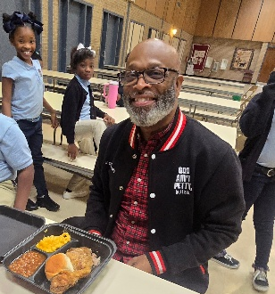
Wednesday was our annual Christmas Luncheon, and when I tell you we ate, drank, and were VERY MERRY—we truly did!
A huge shout-out to G- Mae's Kitchen for catering the lunch. Everything was AMAZING! The food was absolutely delicious, and everyone truly enjoyed every bite.
Most importantly, I want to say THANK YOU to our incredible faculty and staff for your hard work, dedication, and love that you pour into our school every single day. You are truly appreciated more than words can express!
Wishing each of you a very Merry Christmas and a joyful, restful holiday season!
CHRISTMAS PROGRAM
We had an absolutely magnificent Christmas Program last night titled “A Quizzical Christmas.” The acting, singing, dancing—every single part was AMAZING!️
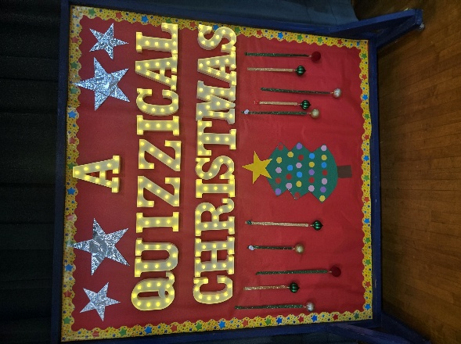
Our students truly shined and brought the spirit of Christmas to life with their talent, confidence, and joy. We are so incredibly proud of each and every one of them for such a wonderful performance!
Thank you to our teachers, staff, parents, and everyone who helped make this special night a success. What a beautiful way to celebrate the season!

KNIGHTS OF PETER CLAVER AND LADIES AUXILIARY
SPIRITUAL REFLECTION
WHAT IF...
What if Mary had said, "No"?
What if Joseph had not obeyed the angel?
What if the inn had not been full?
What if the shepherds had not believed the birth announcement?
What if the wise men had not followed the star?
What if King Herod had found the Baby Jesus?
What if the Savior had not been born?

Silent Night, Holy Night

COMMUNITY
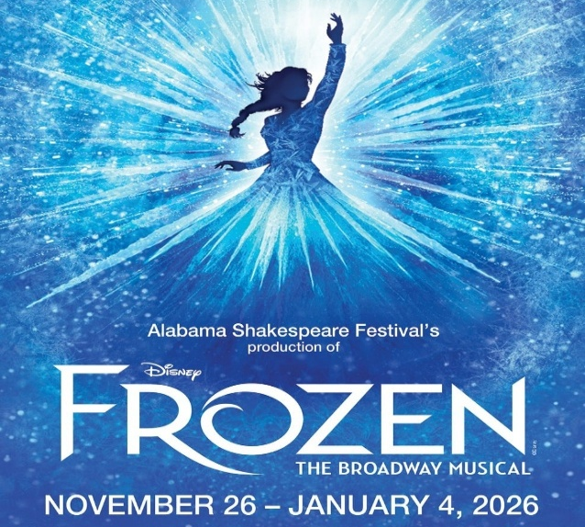
Please check the parish Facebook page as well as the bulletin for the date of the rescheduled parish trip to see “Frozen”.
RESPECT LIFE

"O Blessed Mother, at the angel's word you went in haste to the aid of your cousin Elizabeth. Although pregnant yourself, you placed her needs before your own. By your example of radical solidarity, teach us to reverence and protect those in need. without conditions or expectations. Obtain for us the grace to bring Christ to any expectant mother who is alone and afraid."
USCCB Secretariat of Pro-Life Activities - Prayer for Radical Solidarity
We pray for all parents awaiting the birth of their child. May they look to the Blessed Mother and Saint Joseph and follow their example of cherishing and protecting human life.
INTERFAITH COMMUNITY OUTREACH
RESURRECTION FOOD PANTRY

The Resurrection Food Pantry is available to those who need food assistance. Call (334) 263-4221 to be directed to a staff member who will arrange for a food package to be put together based on the family size.
Do you have busy little ones that find it hard to pay attention for the duration of Mass? If so, we have just the thing for them! You can pick up Children’s Worship Bulletins and crayons from one of the Hospitality Ministers. The Children’s Worship Bulletins also have a “Secret Code” to access fun games online that are tailored to the Sunday readings. We do ask that you return the crayons after Mass.

